**Team Retrospective**

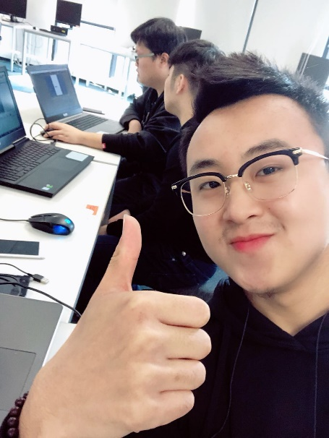

***Time:*** 2:00 -5:00 pm 24/04/18

***Venue:*** WT303

***Attendee:*** Zhi Cui, Jiangliang Liu, Yuanlu Deng

***Agenda:*** In retrospect of sprint 1

* What did we do well, that if we do not disscuss we might forget?

In Sprint 1, we have made considerable progress and each member has contributed that beyond any reasonable measured expectation. In retrospect, we think that we did well part of Sprint 1 which was to find a number of resources about our project whilst the team member who not only just found and post it where we used to share information and resources platform, but also we had to understand what this link or resource dose. It will be therefore easy for others team member whether the resource is useful or not. Moreover, we share resources in this way, meanwhile, it efficiently increases our efficiency. However, indeed, there were sometimes our team member forgot to tell others what this link does, after this, when we team stand-ups meeting, the team leader always reminds us to do that, because in this way it would not waste other’s time to find the resources that they really need.

* What did we learn?

In Sprint 1, on the knowledge layer, we think the most significantly important things we learn which is to use Unity to build our project that no one in our team has used it before. Moreover, we learnt some basic C# programming language. Furthermore, agile methodology has been fully implemented in Sprint 1 through we made a list of features that product owner decided and we prioritized our list so we get the most important stuff done first. In additional, we used Burndown Charts to show how quickly our team are burning through those user stories. Additionally, for Unit Testing, we snipped some our codes for testing to prove that what the developer are developing actually works.

* What should we do differently next sprint?

In Sprint 1, there were indeed lots of missing parts like we always mixed up the initial role that we decided in the start. During processing Sprint 1, Scrum Master sometimes decided what features involved rather than Product owner does. However, at certain point of this, it’s good for our project going, we think that it still impacts some this Scrum team using Agile methodology. We are going to stick closely on our own initially decided role. The second is which we are going to subdivide their own task into small tasks that’s based on their own task already assigned at the start of next Sprint, moreover, the small task will be transferred frequently.

* What still puzzles us?

In Sprint 1, we had basically relied on online tutorials that was teaching us how to achieve our specific functionality. However, we did not spend so much time to learn the syntax of C# programming language. It’s therefore still puzzles us sometimes.